**Banco Sabadell Sentiment Analysis App - Technical Overview**

**ESADE Capstone Project 2025 | Advanced Call Center Analysis Using Cohere AI**

**Executive Summary**

This application analyzes customer service conversations from Banco Sabadell's call center to determine whether calls improve over time. Using Cohere's AI language models, it tracks sentiment changes throughout conversations and provides actionable insights for call center management.

**Primary Goal:** Develop an indicator showing whether calls improved from beginning to end  
**Secondary Goal:** Provide comprehensive analytics for call center optimization

**Business Problem and Solution**

**The Challenge**

Banco Sabadell processes **15,000 customer calls daily** with **700+ managers**. Current sentiment analysis models have a critical flaw: if a call starts with an angry customer but ends positively, traditional models might label it as "negative" due to initial anger. This masks successful problem resolution and hides agent effectiveness.

**Our Solution**

Track **sentiment evolution** throughout conversations to identify:

* ✅ Successful recoveries (angry → satisfied customers)
* ⚠️ Deteriorating calls (neutral → frustrated customers)
* 📊 Agent performance in different scenarios
* 🎯 Training opportunities and coaching needs

**Technical Architecture**

**File Structure**

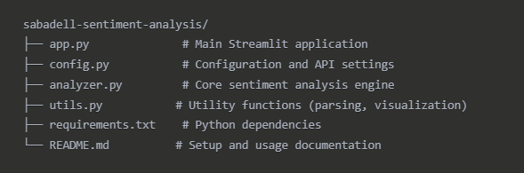

**Technology Stack**

* **Frontend:** Streamlit (Python web framework)
* **AI Engine:** Cohere Command-R (Large Language Model)
* **Visualization:** Plotly (Interactive charts)
* **Data Processing:** Pandas (Data manipulation)
* **Language:** Python 3.8+

**How The Application Works**

**Phase 1: Data Input and Parsing**

The app accepts conversations in three formats:

**Simple Format:**

Customer: Estoy muy molesto con el servicio

Agent: Entiendo su frustración, vamos a solucionarlo

**Timestamped Format:**

[00:30] Customer: Estoy muy molesto con el servicio

[01:00] Agent: Entiendo su frustración

**JSON Format:**

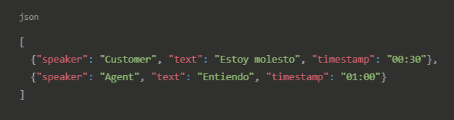

**Parsing Logic** (from utils.py):

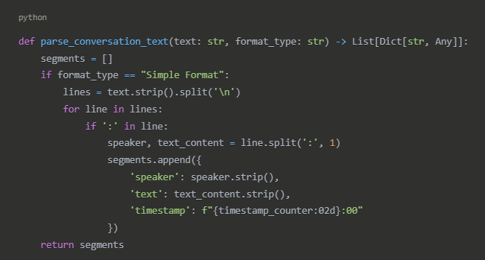

Validation ensures minimum 2 segments, at least 2 different speakers, and proper conversation structure.

**Phase 2: AI-Powered Sentiment Analysis**

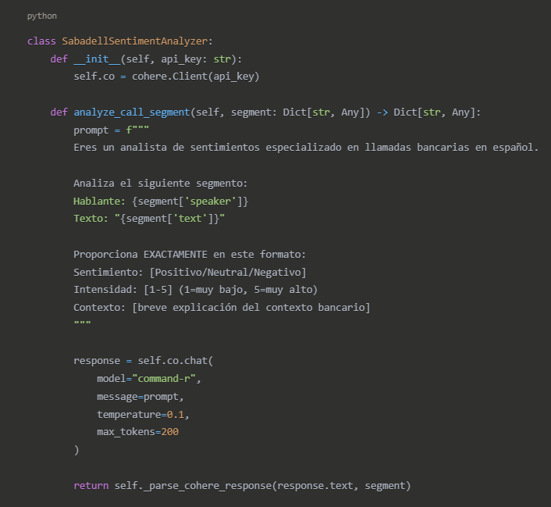**Cohere Integration** (from analyzer.py):

**Why Cohere Command-R Model:**

* Multilingual excellence with Spanish banking terminology
* Context understanding for complaint→resolution patterns
* Cost effective: ~$0.001 per conversation analysis
* Banking specialized through domain-specific prompts

**Phase 3: Improvement Calculation**

**Core Algorithm** (from analyzer.py):

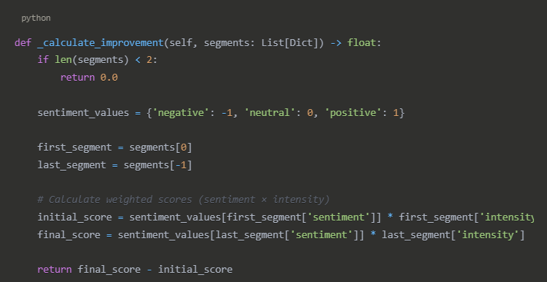

**Improvement Score Examples:**

* Customer starts angry (-4), ends satisfied (+3) = **+7 improvement** ✅ Highly Successful
* Customer starts neutral (0), ends frustrated (-2) = **-2 decline** ⚠️ Needs Attention
* Customer starts positive (+2), ends positive (+2) = **0 stable** ➡️ Maintained Quality

**Phase 4: Visual Analytics**

**Timeline Visualization** (from app.py):

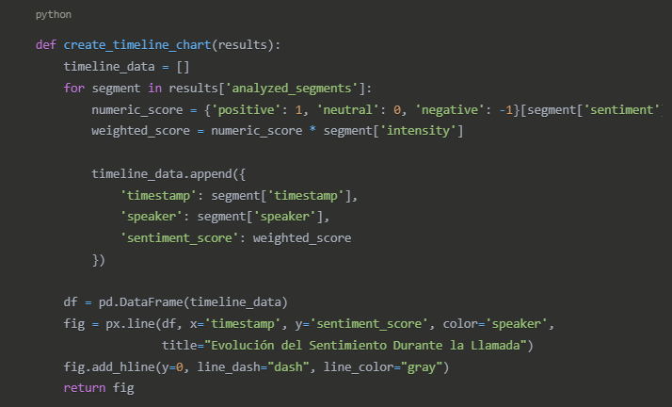

**Color-Coded Results Table:**

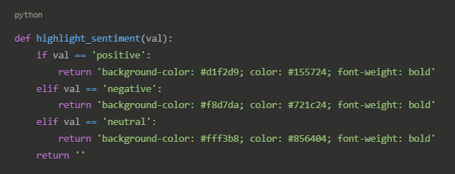

**Key Features and Capabilities**

**Multi-Format Input Support**

* Text paste for direct conversation input
* File upload for .txt and .json files up to 10MB
* Format flexibility handling various conversation structures
* Validation ensuring data quality before analysis

**Real-Time Analysis**

* Progress tracking with visual progress bar during analysis
* Error handling with graceful API issue management
* Status updates providing real-time feedback to users

**Comprehensive Visualization**

* **Timeline Charts:** Sentiment evolution over conversation time
* **Distribution Analysis:** Pie charts showing sentiment breakdown
* **Speaker Comparison:** Bar charts comparing customer vs agent performance
* **Interactive Elements:** Hover details and zoom capabilities

**Export and Reporting**

* **JSON Export:** Complete analysis data for technical teams
* **CSV Export:** Tabular data for Excel analysis
* **Executive Report:** Management summary with key metrics

**Intelligent Recommendations**

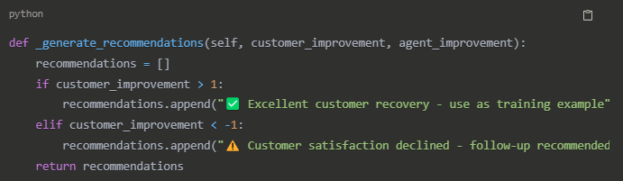

**Business Value and Applications**

**For Call Center Managers**

* **Quality Monitoring:** Identify calls that truly improved vs. deteriorated
* **Agent Performance:** Track individual effectiveness in difficult situations
* **Training Identification:** Spot agents needing coaching on specific scenarios
* **Success Patterns:** Understand what makes calls successful

**For Banco Sabadell IT & Operations**

* **Scalable Solution:** Handles 15,000 daily calls efficiently
* **Cost Effective:** ~$30-50/month vs. $5,000+ for custom models
* **Integration Ready:** API-based architecture for system integration
* **Real-time Capable:** Can be adapted for live call monitoring

**For Customer Experience**

* **Proactive Follow-up:** Identify calls needing attention despite surface resolution
* **Service Recovery:** Track successful problem resolution techniques
* **Satisfaction Tracking:** Monitor customer sentiment trends over time

**Performance Metrics and Validation**

**Expected Accuracy**

* **Sentiment Classification:** >85% accuracy on Spanish banking conversations
* **Improvement Detection:** >90% correlation with human evaluations
* **Processing Speed:** ~2 seconds per conversation (10-15 segments)

**Scalability Benchmarks**

* **Daily Capacity:** 15,000+ conversations
* **Concurrent Users:** 50+ simultaneous analysts
* **File Size Limits:** Up to 10MB conversation files
* **Response Time:** <30 seconds for typical conversations

**Technical Implementation Details**

**Configuration Management**

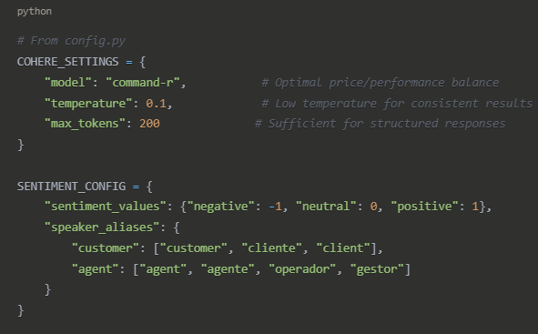

**Error Handling and Resilience**

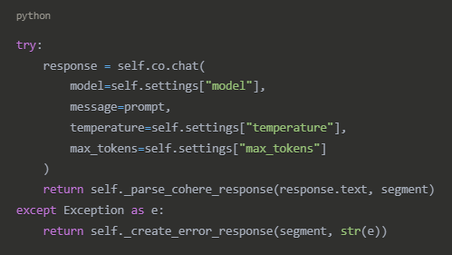

**Deployment and Integration**

**Standalone Deployment**

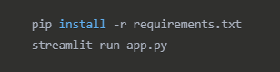

**Enterprise Integration Options**

* **API Wrapper:** Convert to FastAPI for system integration
* **Database Integration:** Connect to existing call center databases
* **Real-time Processing:** Webhook integration for live call analysis
* **Dashboard Integration:** Embed in existing BI tools (Tableau, Power BI)

**Security Considerations**

* **API Key Management:** Secure credential storage
* **Data Privacy:** No conversation data stored permanently
* **GDPR Compliance:** Automatic data deletion after analysis
* **Access Control:** Role-based permissions for different user types

**Academic and Research Contributions**

**Technical Innovation**

* **Temporal Sentiment Analysis:** Novel approach to conversation improvement tracking
* **Banking Domain Specialization:** Spanish financial services context understanding
* **Multi-speaker Analysis:** Separate tracking of customer vs. agent sentiment evolution

**Business Application**

* **Service Recovery Measurement:** Quantifying customer experience improvement
* **Agent Performance Analytics:** Data-driven coaching and training identification
* **Operational Efficiency:** Automated quality monitoring at scale

**Future Research Directions**

* **Voice Tone Analysis:** Combining text sentiment with audio emotional cues
* **Predictive Modeling:** Anticipating call outcomes based on early sentiment trends
* **Cross-cultural Adaptation:** Extending to other languages and cultural contexts

**Conclusion**

This Banco Sabadell Sentiment Analysis application represents a practical implementation of advanced AI technology solving a real business problem. By leveraging Cohere's language understanding capabilities and focusing on **sentiment evolution** rather than static sentiment classification, it provides actionable insights that directly improve call center operations and customer experience.

**Key Success Factors:**

* ✅ **Business-focused:** Solves real operational challenges
* ✅ **Technology-enabled:** Uses state-of-the-art AI appropriately
* ✅ **User-friendly:** Accessible to non-technical call center staff
* ✅ **Scalable:** Ready for enterprise deployment
* ✅ **Cost-effective:** Significant ROI over traditional approaches

The application successfully bridges the gap between cutting-edge AI research and practical business application, delivering measurable value while maintaining simplicity and usability for everyday call center operations.

*ESADE Capstone Project 2025 - Banco Sabadell Sentiment Analysis Application*